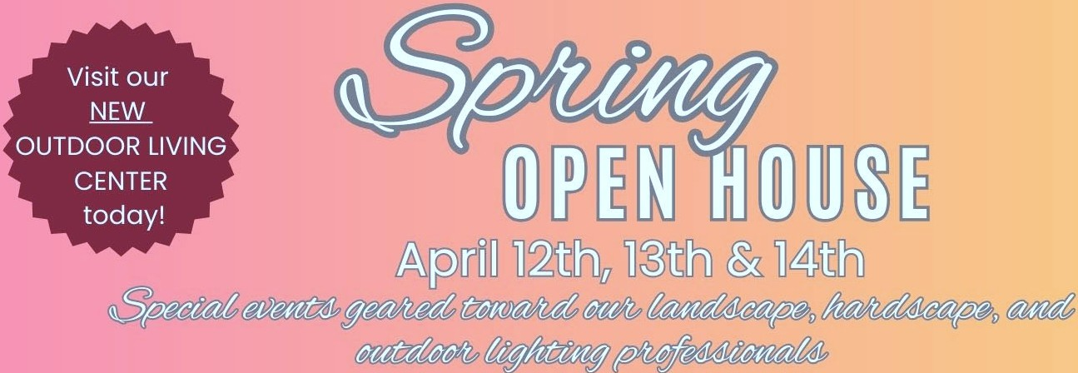

# Saturday, April 12th from 10 am-2 pm

***11Meet your Local Landscaper"***

Connect with homeowners and small business owners looking for top experts in landscaping, hardscaping, and outdoor lighting to enhance their outdoor spaces! Explore our latest products designed to inspire and help clients bring their vision to life. This event has been widely promoted through mailers, emails, and social media,making it a prime opportunity to match homeowners and businesses with the perfect outdoor living professionals in lawns, gardens, & patios!

# Monday, April 14th from 10 am-2 pm

*11Ask the Experts"*

Manufacturer representatives from all areas of the outdoor living industry will bepresent. Exhibitors will present new products and conduct live demonstrations from leading brands including Belgard, Unilock, Techo Bloc, Tru-Scapes Lighting, Alpha Tools, Empire Distributing, Pave Tool, SRW Products,

Alliance Outdoor Lighting, and Stateline Irrigation!

Let us know if you'll beattending by emailing [denise.dolloff@freshwaterfarms.net](mailto:denise.dolloff@freshwaterfarms.net)

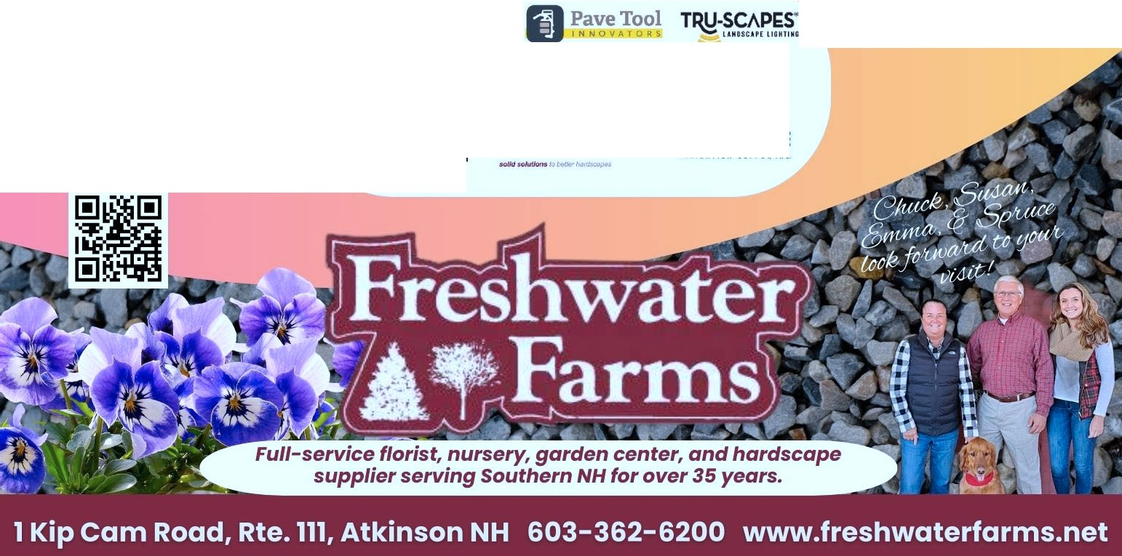

**I**BEL**I**GARD

�

r l!11m,

**unu.or.c**

**S wi·**

PRODUCTS

---·--·-·.··-·-·

::stateline

IAIIIGATIOH IUP'l'LY, INC.

§ E, *IJ;*